**UPGRADING CLUSTER FROM 4.7.49 to 4.8.39**

**First we have login to the console of dev server**

console-openshift-console.apps.idopadev15.insight.local

Then go to administration

Click on cluster setting

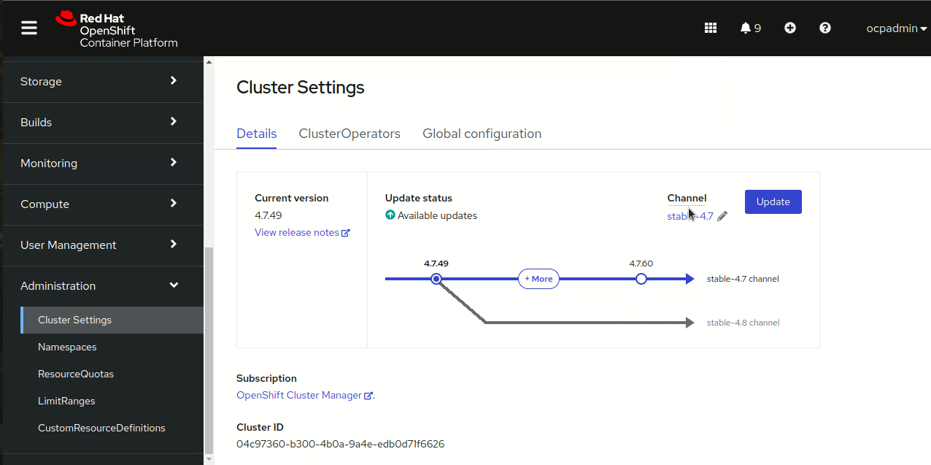

Select the channel then click on the version to which we have to upgrade then save it

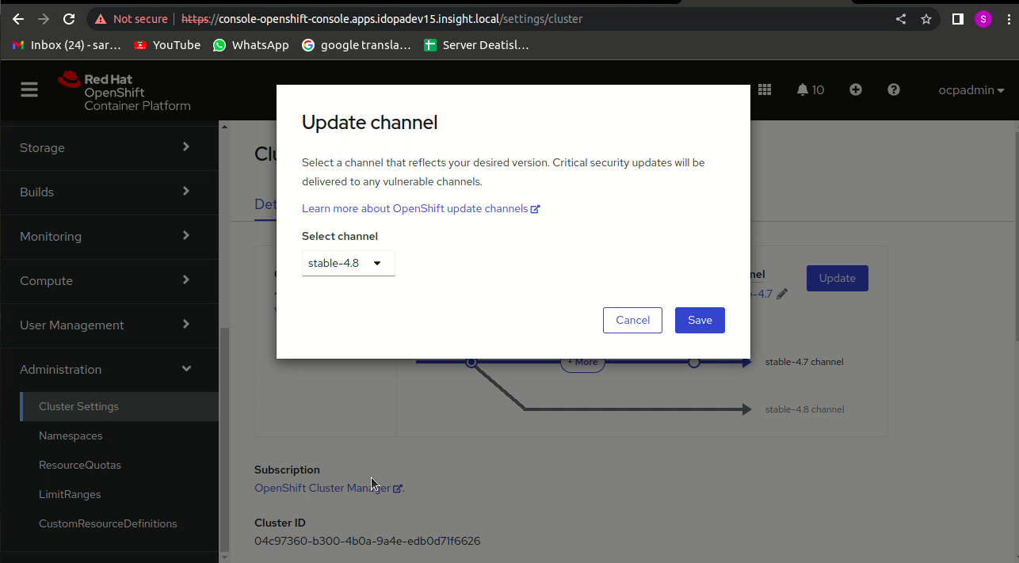

Then click on upgrade option then select the new version in which we have to upgrade

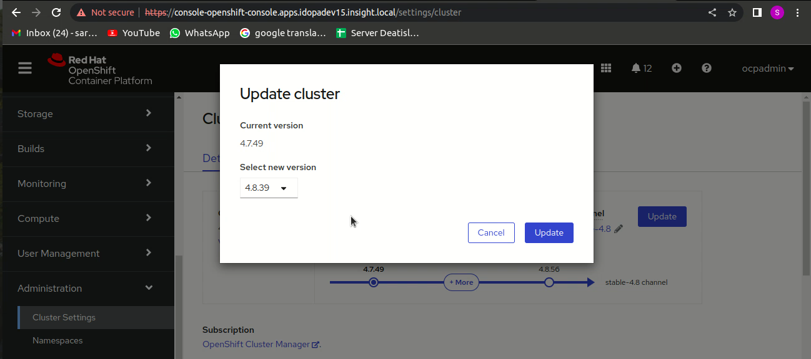

Then watch till it upgrade

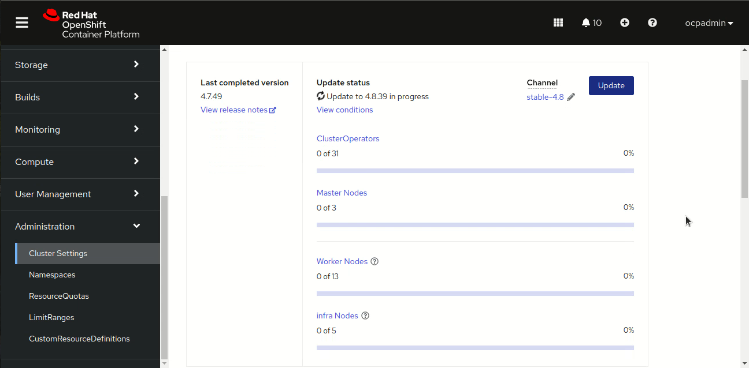

**Then take ssh of the dev server on cli**

Then run some to check the upgradation

[ocpadmin@bastion ~]$ **oc get node**

NAME STATUS ROLES AGE VERSION

idopadev01.insight.local Ready worker 680d v1.21.8+ed4d8fd

idopadev02.insight.local Ready worker 678d v1.20.14+0d60930

idopadev03.insight.local Ready,SchedulingDisabled worker 678d v1.20.14+0d60930

idopadev04.insight.local Ready worker 678d v1.21.8+ed4d8fd

idopadev05.insight.local Ready worker 678d v1.20.14+0d60930

idopadev06.insight.local Ready worker 678d v1.21.8+ed4d8fd

idopadev07.insight.local Ready worker 678d v1.20.14+0d60930

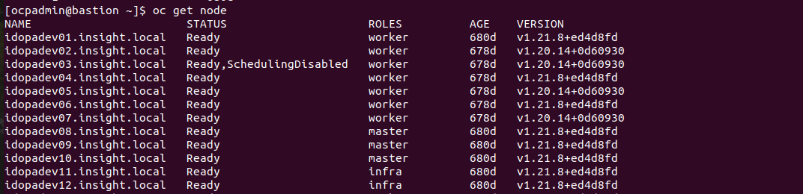

[ocpadmin@bastion ~]$ **oc get mcp**

NAME CONFIG UPDATED UPDATING DEGRADED MACHINECOUNT READYMACHINECOUNT UPDATEDMACHINECOUNT DEGRADEDMACHINECOUNT AGE

infra rendered-infra-031965ea17141232ad7996e334289ad0 True False False 5 5 5 0 680d

master rendered-master-661acd14ca877c29d95c324dd4ac91b8 True False False 3 3 3 0 680d

worker rendered-worker-d6babcbf244262478b92ad73e5278758 False True True 13 8 8 1 680d

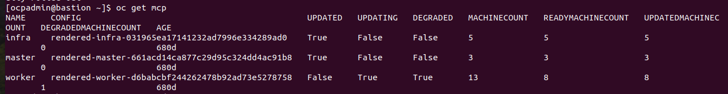

[ocpadmin@bastion ~]$ **oc get co**

NAME VERSION AVAILABLE PROGRESSING DEGRADED SINCE

authentication 4.8.39 True False False 3m21s

baremetal 4.8.39 True False False 49d

cloud-credential 4.8.39 True False False 680d

cluster-autoscaler 4.8.39 True False False 680d

config-operator 4.8.39 True False False 680d

console 4.8.39 True False False 3h9m

csi-snapshot-controller 4.8.39 True False False 4h13m

dns 4.8.39 True True False 3h40m

etcd 4.8.39 True False False 680d

image-registry 4.8.39 True False False 173m

ingress 4.8.39 True False False 3h21m

insights 4.8.39 True False False 680d

kube-apiserver 4.8.39 True False False 680d

kube-controller-manager 4.8.39 True False False 680d

kube-scheduler 4.8.39 True False False 680d

kube-storage-version-migrator 4.8.39 True False False 3h21m

machine-api 4.8.39 True False False 680d

machine-approver 4.8.39 True False False 680d

machine-config 4.8.39 True False False 21m

marketplace 4.8.39 True False False 49d

monitoring 4.8.39 True False False 174m

network 4.8.39 True True False 680d

node-tuning 4.8.39 True False False 3m42s

openshift-apiserver 4.8.39 True False False 3m19s

openshift-controller-manager 4.8.39 True False False 3h52m

openshift-samples 4.8.39 True False False 3h56m

operator-lifecycle-manager 4.8.39 True False False 680d

operator-lifecycle-manager-catalog 4.8.39 True False False 680d

operator-lifecycle-manager-packageserver 4.8.39 True False False 4h33m

service-ca 4.8.39 True False False 680d

storage 4.8.39 True False False 680d

